Assignment 5
Ling 201 – Spring 2026
(100 pts total)
Please do not share answers with other students and do not use external sources such as the internet or AI to find the answers. If you need an extension, please ask before the deadline.

Set theory
It’s Picture Day at Berry Grove School! Here’s the class photo for Mrs. Calico’s third grade class:
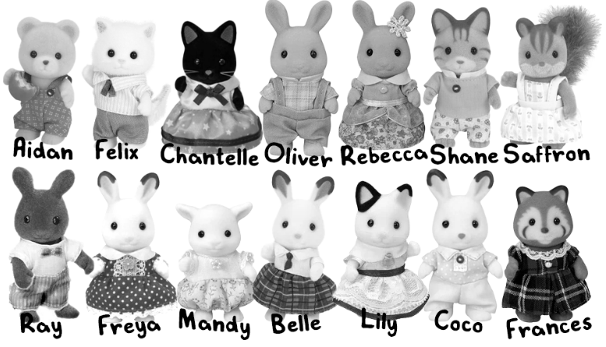
Answer the following questions, assuming the following subsets of Mrs. Calico’s class:
- B = { x | x is a bunny } = { Oliver, Rebecca, Ray, Freya, Belle, Coco }
- C = { x | x is a cat } = { Felix, Chantelle, Shane, Lily }
- D = { x | x is wearing a dress } = { Chantelle, Rebecca, Saffron, Freya, Mandy, Belle, Lily, Frances }
- N = { x | x is wearing a necktie } = { Felix, Chantelle, Ray, Belle, Lily }
- S = { x | x has stripes on their face } = { Shane, Saffron, Frances }
- W = { x | x has white fur } = { Felix, Freya, Mandy, Belle, Lily, Coco }

a. State whether the expression is true or false and briefly explain why (7 points/item, 35 points total):
    - |B| = |D|

    - C ∩ S ≠ ∅

    - Saffron ∈ ( N ∩ D )

    - N ⊆ D

    - Frances ∈ W ′

b. Calculate the following and describe the resulting set in words (7 points/item, 35 points total):
Example: C – S
Calculated set: {Felix, Chantelle, Lily}
Description in words: cats without stripes on their faces

i. D ∩ W

ii. C – D

iii. C ∩ W ′

iv. ( B ∪ C )′

v. W – ( B ∪ D )

c. Define two more subsets of Mrs. Calico’s class to add to the top list. Use both predicate notation and list notation for each set (3 points/item, 6 points total):

i. ____ = { x | x________________} = { ___________________________}

ii. ____ = {x | x________________} = { ___________________________}

d. Using these two sets alongside the sets already given, come up with three phrases that could describe the students of Mrs. Calico’s class. Represent the phrase in set notation, then calculate the resulting set and write it in list notation. You must use at least two operators in the sentence, out of the following: union (∪), intersection (∩), difference (–), complement (′)
(8 points/item, 24 points total).
Example: Phrase: cats without white fur wearing a necktie
In set notation: C ∩ W ′ ∩ N = {Chantelle}

    - Phrase 1: ____________________________________________________________________________
In set notation: __________________________ = { _____________________________________ }

    - Phrase 2: ____________________________________________________________________________
In set notation: __________________________ = { _____________________________________ }

    - Phrase 3: ____________________________________________________________________________
In set notation: __________________________ = { _____________________________________ }

